AI Assisted Problem Solving Using Python

NAME : SYEDA AFIFA FATHIMA
HT.NO : 2503B05142
Program Name: M.Tech (CSE)

Lab 4: Advanced Prompt Engineering – Zero-shot, One-shot, and Few-shot Techniques

Task Description#1
● Zero-shot: Prompt AI to write a function that checks whether a given year is a leap
year.
Expected Output#1
● AI-generated function with no examples provided
Prompt:
Write a function that checks whether a given year is a leap year or not.

CODE:
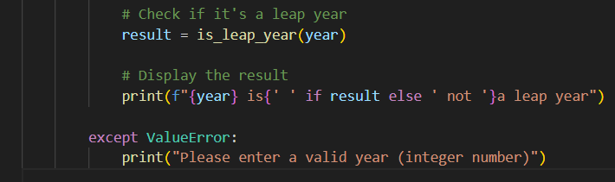
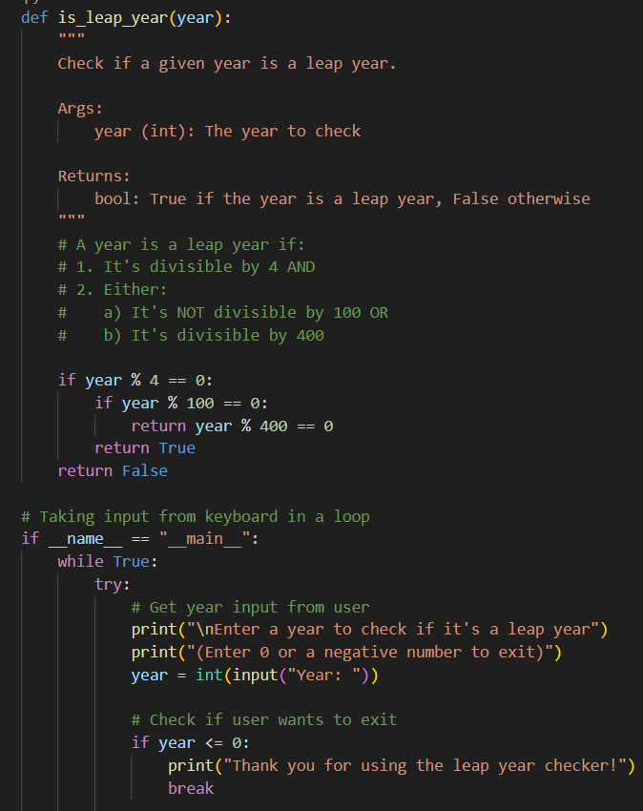

OUTPUT:
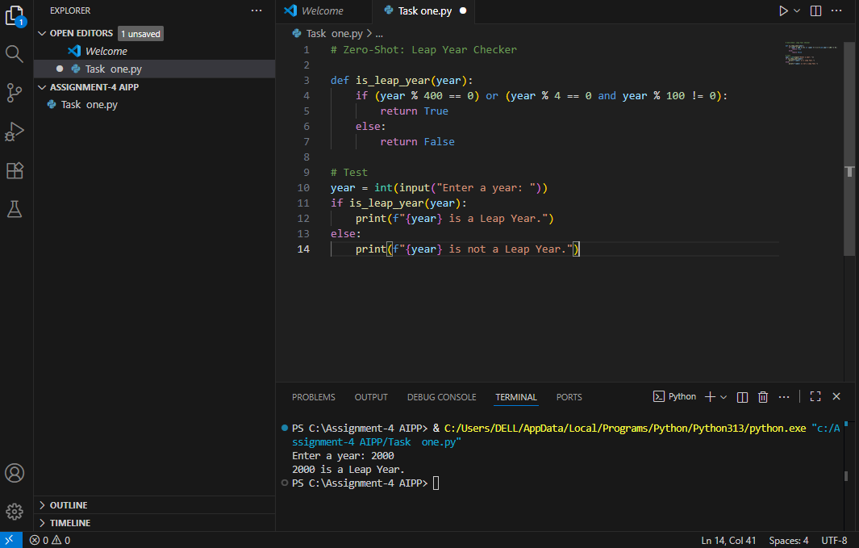

Task Description#2
● One-shot: Give one input-output example to guide AI in writing a function that
converts centimeters to inches.
Expected Output#2
● Function with correct conversion logic
Prompt :
Write a a function that converts centimeters to inches like 1cm = 0.39370079 inches.

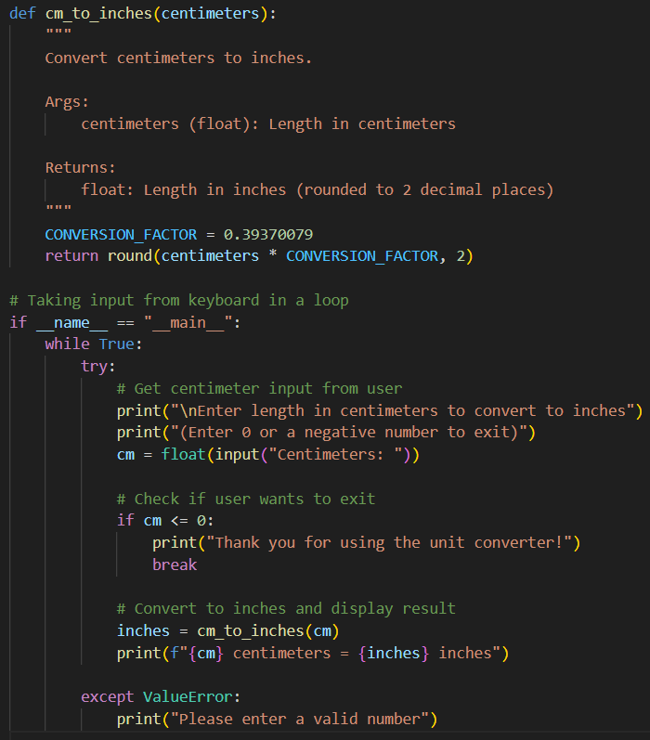
CODE:

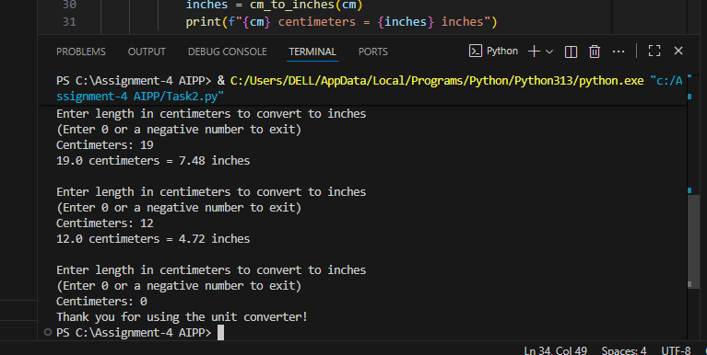
OUTPUT:

Task Description#3
● Few-shot: Provide 2–3 examples to generate a function that formats full names as
“Last, First”.
Expected Output#3
● Well-structured function respecting the examples
Prompt :
Generate a function that formats full names as “Last, First”. Like “Evancy, Manne” , “Kavya, Kedem”, “Pujitha, Chittimalla”.
CODE:
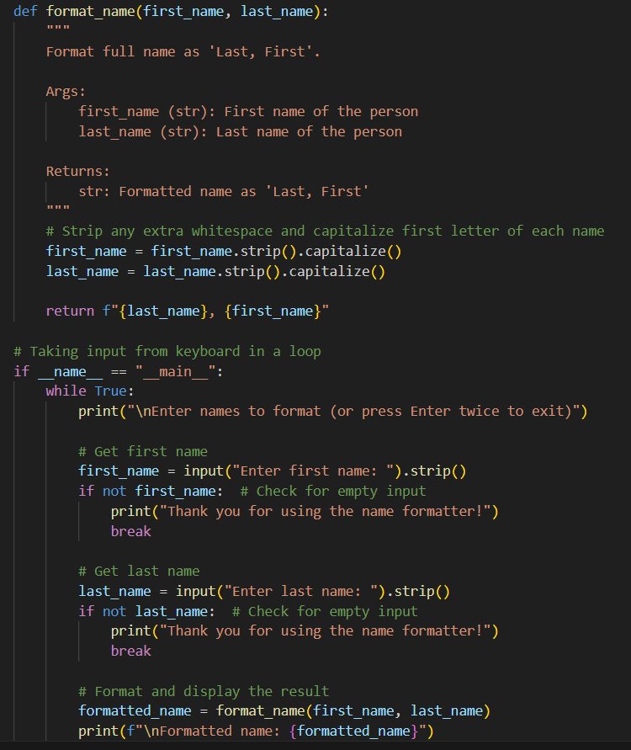

OUTPUT:
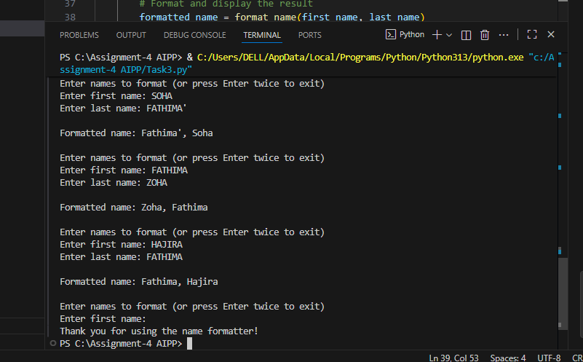

Task Description#4
● Compare zero-shot and few-shot prompts for writing a function that counts the
number of vowels in a string.
Expected Output#4
● Functional output and comparative reflection
Zero-Shot Prompt :
Generate a function that counts the number of vowels in a string.
Few-Shot Prompt :
Generate a function that counts the number of vowels in a string. Like in madam = 2 vowels, generation = 5 vowels, monday = 2 vowels, wednesday = 3 vowels

Zero-Shot Code:

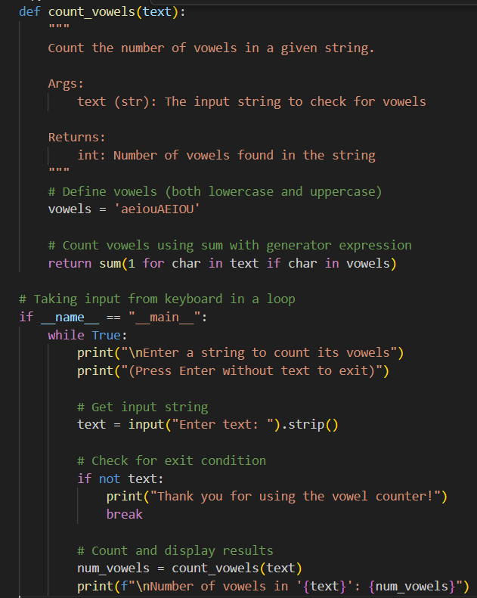

Zero-Shot Output:

Few-Shot Code:
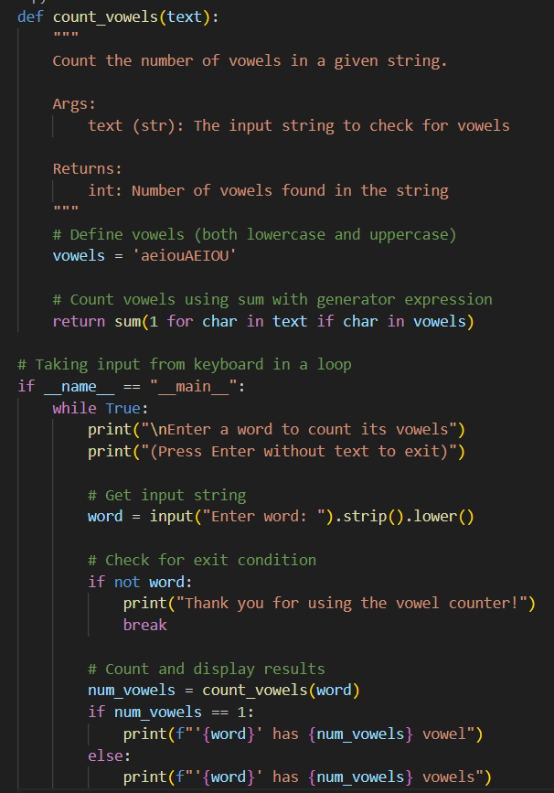

Zero-Shot Output and Few-Shot Output:
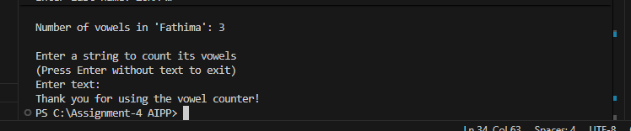

Zero-Shot

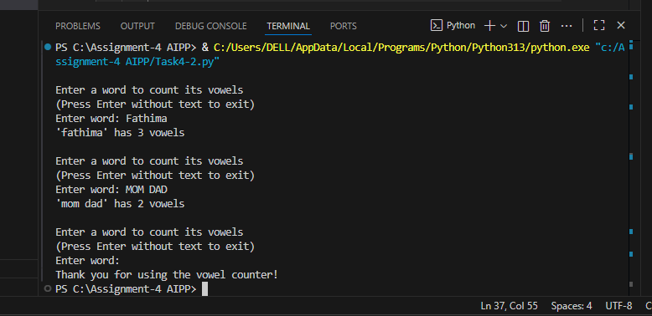

Few-Shot

Comparision:
For the specific task of writing a function to count the number of vowels in a string, the zero-shot prompt is more suitable. As the task is simple and well-defined. The model can reliably generate correct code without examples. It’s faster and requires less setup .Whereas, Few-shot prompting is better reserved for Complex tasks, Style-sensitive outputs , Situations where consistency with prior examples matters.
Task Description#5
● Use few-shot prompting to generate a function that reads a .txt file and returns the
number of lines.
Expected Output#5
● Working file-processing function with AI-guided logic
Prompt:
Write a Python function that takes the file path as input and returns the number of lines in a text file.
Examples:
1) File path : .\xxxx.docx
File Content:
Line 1
Line 2
Line 3
-> function should return: 3

2) Empty file (no bytes)
-> function should return: 0

3) File Path : C:\\Downloads.\xxxxx.pdf
File content:
a
b
c
d
-> function should return: 4

4) Path is missing:
-> function should raise FileNotFoundError

CODE:
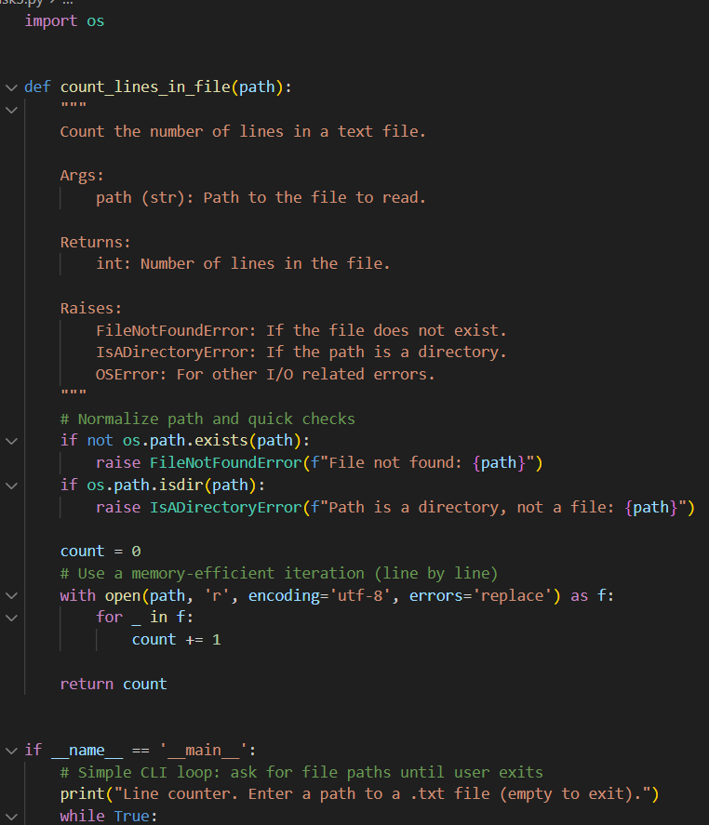
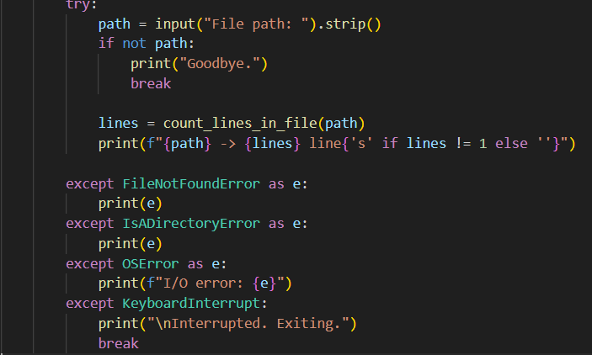

OUTPUT:

